SmartStudy — AI Academic Planning Agent
Stage 1: Software and Agent Design
Negin Ghoghaei | Student Number: 220989380

Task 1 — Define the Agent Project

1.1 Project Description
SmartStudy is an academic planning assistant for university students managing several courses at once. Deadlines can be scattered across syllabi, announcements, and personal notes, and students often underestimate how long assignments will take. The proposed system brings those pieces together, recommends a practical weekly plan, and helps students adjust it when circumstances change.
The target users are university and college students who need to coordinate assignments, quizzes, exams, and study sessions. SmartStudy is not intended to replace academic judgment. Students can inspect extracted dates, edit priorities, and approve changes before they affect the calendar.
I plan to use an OpenAI GPT model through an API, wrapped by an LLMAdapter interface. The model will interpret natural-language requests, identify candidate deadlines from text, and explain plans. A separate rule-based scheduling engine will handle available time, priority scores, and conflicts. This division matters because an LLM can be helpful with messy language but should not be trusted to invent dates or guarantee that two calendar sessions do not overlap.

1.2 Interfaces and Overall Architecture
The graphical interface will contain a course/task dashboard, a weekly calendar, a document-import screen, and an assistant chat panel. A command-line interface will expose the same major services through commands such as `smartstudy task add`, `smartstudy import outline.pdf`, `smartstudy plan week`, `smartstudy task complete`, `smartstudy replan`, and `smartstudy export csv`. Both interfaces call AgentController rather than duplicating business logic.
The proposed implementation uses Python, SQLite, a PDF text extraction library, and an LLM API. AgentController coordinates the steps, while TaskManager, SchedulePlanner, and repositories perform specific jobs. The agent can decide which approved tool to call, but actions that change stored tasks or calendars are validated and require confirmation where appropriate.

1.3 Detailed Feature Specifications

F01 — Natural-language requests
Description: Natural-language requests supports students in managing academic work through SmartStudy.
GUI interaction: A student types a question or instruction in the assistant panel.
Input: Text request and current context. Output: Structured intent and response. AI involvement: Hybrid.
Expected workflow: Controller interprets the request, selects permitted tools, and reports results.
Error/alternative cases: Unclear intent prompts a clarification; model failure offers manual navigation.

F02 — Course and task management
Description: Course and task management supports students in managing academic work through SmartStudy.
GUI interaction: Students add courses and edit assignments in the dashboard.
Input: Course code, task title, due date, estimated effort. Output: Saved courses and tasks. AI involvement: Deterministic.
Expected workflow: Validate entered fields and store records; refresh dashboard.
Error/alternative cases: Invalid dates or missing titles are highlighted.

F03 — Course-outline PDF import
Description: Course-outline PDF import supports students in managing academic work through SmartStudy.
GUI interaction: Students upload a course outline and review suggested deadlines.
Input: Selectable-text PDF. Output: Editable draft assignments and exams. AI involvement: Hybrid.
Expected workflow: Extract PDF text, ask the model for structured items, validate and confirm before saving.
Error/alternative cases: Unsupported/scanned PDF or ambiguous dates require manual entry.

F04 — Deadline extraction from notes
Description: Deadline extraction from notes supports students in managing academic work through SmartStudy.
GUI interaction: Students paste a course announcement into the assistant.
Input: Announcement text. Output: Proposed task with due date. AI involvement: Hybrid.
Expected workflow: Model identifies a possible deadline; validator checks date and requests confirmation.
Error/alternative cases: Missing or relative dates are flagged rather than guessed.

F05 — Priority ranking
Description: Priority ranking supports students in managing academic work through SmartStudy.
GUI interaction: Students select “Sort by priority” on the task board.
Input: Due dates, importance, remaining effort. Output: Ordered task list with scores. AI involvement: Deterministic.
Expected workflow: PriorityEngine scores tasks using configurable rules and sorts pending work.
Error/alternative cases: Missing deadlines are placed in a separate review group.

F06 — Weekly study-plan generation
Description: Weekly study-plan generation supports students in managing academic work through SmartStudy.
GUI interaction: Students choose a week and click “Generate plan.”
Input: Pending tasks, availability, commitments. Output: Proposed study sessions and unscheduled work. AI involvement: Hybrid.
Expected workflow: Agent gathers data; planner allocates slots; conflict checker validates; student approves.
Error/alternative cases: Insufficient time produces a partial proposal and warning.

F07 — Conflict detection
Description: Conflict detection supports students in managing academic work through SmartStudy.
GUI interaction: Students open the calendar or add a commitment.
Input: Proposed sessions and blocked periods. Output: Conflict list with affected times. AI involvement: Deterministic.
Expected workflow: Checker compares time intervals and marks overlapping or late sessions.
Error/alternative cases: Invalid intervals are rejected with an explanation.

F08 — Progress tracking
Description: Progress tracking supports students in managing academic work through SmartStudy.
GUI interaction: Students mark a task complete or update remaining minutes.
Input: Task ID, status, remaining minutes. Output: Updated task and progress summary. AI involvement: Deterministic.
Expected workflow: TaskManager validates and persists changes, then refreshes the view.
Error/alternative cases: Unknown task or negative effort is rejected.

F09 — Automatic replanning proposal
Description: Automatic replanning proposal supports students in managing academic work through SmartStudy.
GUI interaction: Students click “Replan” after a change or ask in chat.
Input: Updated tasks, existing sessions, availability. Output: Revised schedule preview. AI involvement: Hybrid.
Expected workflow: Controller fetches current state; planner proposes changes; checker validates; user approves.
Error/alternative cases: If no valid solution exists, show unresolved tasks and keep the old plan.

F10 — Deadline reminders
Description: Deadline reminders supports students in managing academic work through SmartStudy.
GUI interaction: Students enable reminders in task settings.
Input: Deadline, reminder lead time, preference. Output: In-app reminder or delivery status. AI involvement: Deterministic.
Expected workflow: Scheduler finds eligible tasks, checks delivery history, and notifies once.
Error/alternative cases: Failed deliveries are retried and duplicate alerts suppressed.

F11 — Study-plan explanation
Description: Study-plan explanation supports students in managing academic work through SmartStudy.
GUI interaction: Students click “Why this plan?” beside the schedule.
Input: Ranked tasks, planning decisions, schedule. Output: Readable rationale grounded in task data. AI involvement: Hybrid.
Expected workflow: ExplanationService prepares verified scheduling facts for the LLM to summarize.
Error/alternative cases: If the model fails, show a template-based explanation.

F12 — Plan export and CLI access
Description: Plan export and CLI access supports students in managing academic work through SmartStudy.
GUI interaction: Students choose Export in GUI or run a CLI command.
Input: Selected date range, export format. Output: CSV study plan; terminal output. AI involvement: Deterministic.
Expected workflow: Shared controller retrieves schedule and ExportService formats the result.
Error/alternative cases: Invalid commands/formats display help without changing data.

Task 2 — UML System Design

2.1 UML Use-Case Diagram
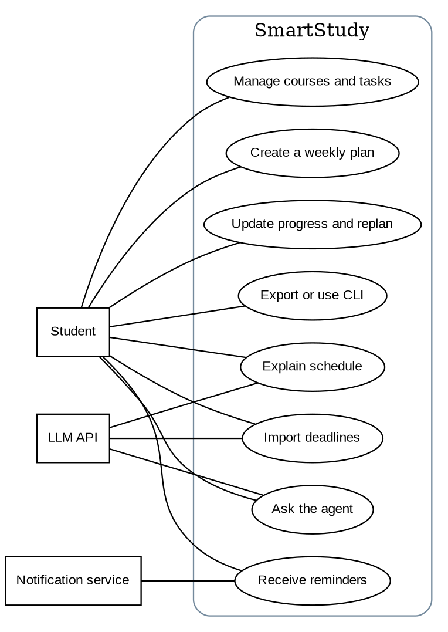
Figure 1. Major use cases and external actors.

2.2 Detailed Use Cases

UC01 — Ask the agent
Field | Specification
Actors | Student; LLM service
Goal | Interpret a study-related request
Preconditions | Application running
Trigger | Student submits chat text
Related features | F01, F11
Postconditions | Request answered or clarified.
Main success scenario:
1. UI or CLI passes text to AgentController.
2. IntentInterpreter asks LLMAdapter for structured intent.
3. Controller selects the appropriate service or tool.
4. System returns the result and an explanation.
Alternative/exception flows: If intent is unclear, ask a question; if API fails, show an error or manual option.

UC02 — Manage courses and tasks
Field | Specification
Actors | Student
Goal | Keep course tasks accurate and prioritized
Preconditions | Local database available
Trigger | Student creates or edits a task
Related features | F02, F05
Postconditions | Saved task list and ranking updated.
Main success scenario:
1. Student enters course/task fields.
2. TaskManager validates and saves them.
3. PriorityEngine ranks unfinished tasks.
4. Updated task board is displayed.
Alternative/exception flows: Invalid fields are rejected; database errors do not claim success.

UC03 — Import deadlines
Field | Specification
Actors | Student; LLM service
Goal | Turn documents or announcements into confirmed tasks
Preconditions | PDF text or announcement available
Trigger | Student uploads/pastes content
Related features | F03, F04
Postconditions | Confirmed deadlines saved.
Main success scenario:
1. DocumentProcessor extracts text or accepts pasted text.
2. LLMAdapter produces structured deadline drafts.
3. TaskValidator checks each draft.
4. Student corrects and confirms suggested tasks.
5. TaskManager stores approved tasks.
Alternative/exception flows: Unreadable file, uncertain date, or unavailable AI leads to manual entry.

UC04 — Create a weekly plan
Field | Specification
Actors | Student
Goal | Allocate work without time conflicts
Preconditions | Tasks and availability recorded
Trigger | Student requests a plan
Related features | F06, F07
Postconditions | Approved conflict-checked plan stored.
Main success scenario:
1. Controller retrieves tasks and calendar availability.
2. PriorityEngine orders unfinished tasks.
3. SchedulePlanner creates proposed study sessions.
4. ConflictChecker validates the proposal.
5. Student approves; repository saves sessions.
Alternative/exception flows: If time is insufficient, display unplaced work; cancellation discards proposal.

UC05 — Update progress and replan
Field | Specification
Actors | Student
Goal | Adjust plan after work or availability changes
Preconditions | Tasks and schedule exist
Trigger | Student updates progress or availability
Related features | F08, F09
Postconditions | Progress stored; approved revision saved.
Main success scenario:
1. TaskManager updates progress.
2. Controller loads unfinished tasks and existing sessions.
3. SchedulePlanner prepares a revision.
4. ConflictChecker verifies proposed changes.
5. Student reviews differences and confirms.
Alternative/exception flows: If conflicts remain, show them; if rejected, preserve original sessions.

UC06 — Receive reminders
Field | Specification
Actors | Student; notification service
Goal | Know about approaching deadlines
Preconditions | Reminders enabled
Trigger | ReminderScheduler runs
Related features | F10
Postconditions | Reminder delivered or pending retry.
Main success scenario:
1. Scheduler reads upcoming tasks.
2. Reminder history is checked.
3. NotificationService sends eligible alerts.
4. Successful delivery is recorded.
Alternative/exception flows: Delivery failure is logged for retry; duplicates are skipped.

UC07 — Explain schedule
Field | Specification
Actors | Student; LLM service
Goal | Understand why tasks were scheduled
Preconditions | Schedule exists
Trigger | Student requests explanation
Related features | F11
Postconditions | Student sees rationale.
Main success scenario:
1. ExplanationService gathers scores and scheduling facts.
2. LLMAdapter generates a plain-language summary grounded in those facts.
3. UI displays explanation alongside the plan.
Alternative/exception flows: On AI failure, display a deterministic summary.

UC08 — Export or use CLI
Field | Specification
Actors | Student
Goal | Use major functions without GUI and export plans
Preconditions | Application running
Trigger | Student enters CLI command or clicks Export
Related features | F12, F01–F10
Postconditions | Requested output produced.
Main success scenario:
1. CLI parses command and calls AgentController.
2. Controller runs the same application service as GUI.
3. ExportService creates CSV or CLI renders the returned result.
4. Output or validation message is shown.
Alternative/exception flows: Bad arguments show help; export failure preserves stored data.

2.3 UML Class Diagram
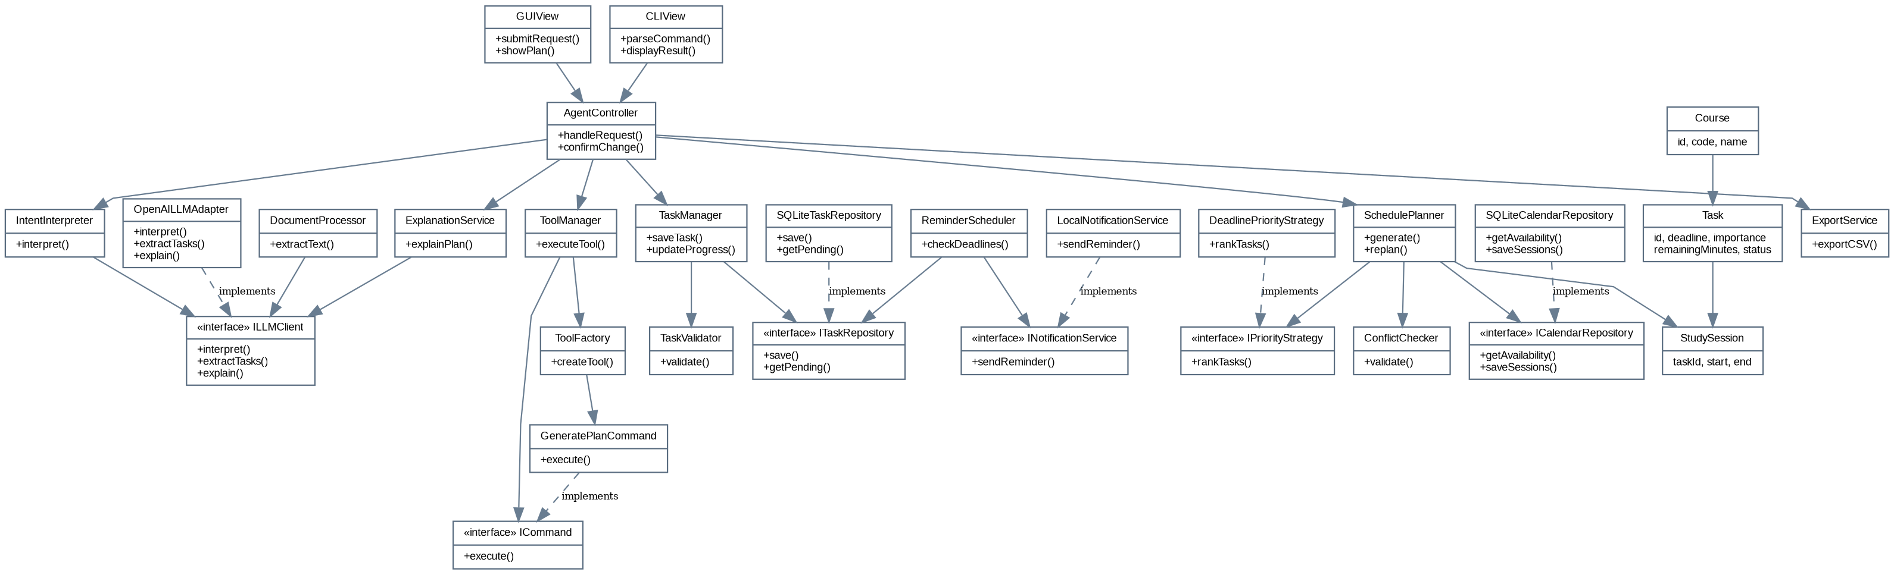
Figure 2. UML class structure. Solid arrows indicate use/association; dashed arrows indicate interface realization. Course has many Tasks; each Task can have many StudySessions.
Composition is used conceptually where the controller owns workflow services; repository and model dependencies are injected as interfaces. The task-to-session relationship is one-to-many, while each session belongs to one task. The Task entity encapsulates its status and remaining effort.

2.4 Design Patterns

Strategy
Participants: PriorityEngine uses IPriorityStrategy and DeadlinePriorityStrategy.
Problem: Task ranking may need different rules for exam weeks or normal weeks.
Why appropriate: Swapping a strategy changes scoring without rewriting the planner; otherwise priority rules would be tangled with scheduling.

Adapter
Participants: ILLMClient and OpenAILLMAdapter.
Problem: The model API has provider-specific request and response formats.
Why appropriate: The adapter presents a stable interface to IntentInterpreter, DocumentProcessor, and ExplanationService; without it, those classes would depend on provider details.

Facade
Participants: AgentController with GUIView and CLIView as clients.
Problem: Many services are needed to complete one user request.
Why appropriate: The controller provides a single entry point; otherwise both interfaces would coordinate repositories, planning, and validation independently.

Command
Participants: ICommand, GeneratePlanCommand, ToolManager, and ToolFactory.
Problem: The agent needs to select a bounded operation from a request.
Why appropriate: Each permitted action is represented as an executable command; without it, tool selection becomes a large conditional block.

Factory Method
Participants: ToolFactory creates command/tool objects used by ToolManager.
Problem: Different intents require different executable actions.
Why appropriate: Construction is centralized so new actions can be added without changing the interfaces.

Observer
Participants: TaskEventPublisher and ReminderScheduler/CalendarRefreshListener (planned supporting classes).
Problem: Task changes should trigger schedule refresh and reminder checks.
Why appropriate: Listeners subscribe to task-change events instead of TaskManager directly calling every downstream service; without this, TaskManager gains unrelated responsibilities.
The first five patterns are represented directly in the main class structure. For the Observer extension, TaskEventPublisher maintains subscribers and notifies ReminderScheduler and CalendarRefreshListener after a task update; these are supporting classes that can be added in Stage 2.

2.5 Sequence Diagrams
These runtime diagrams use the controller, repository, parser, planner, and notification services described above. The alternate cases are stated directly below each diagram.
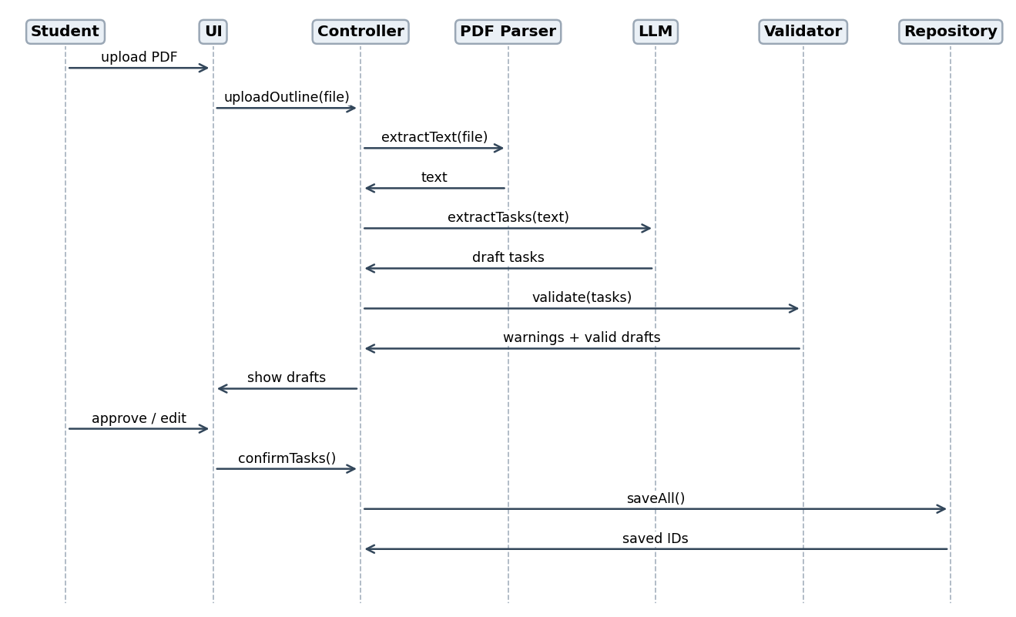
SD01 — Import and confirm extracted deadlines.
Alternative flow: If validation fails, the draft is returned for correction; no tasks are saved without confirmation.
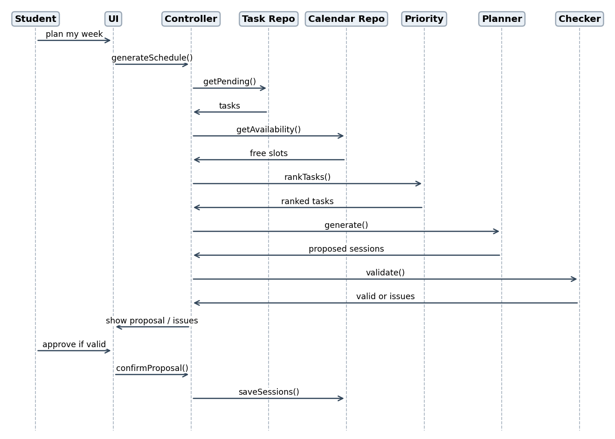
SD02 — Generate and confirm a study plan.
Alternative flow: If the checker finds conflicts or the student cancels, the proposal is not committed.
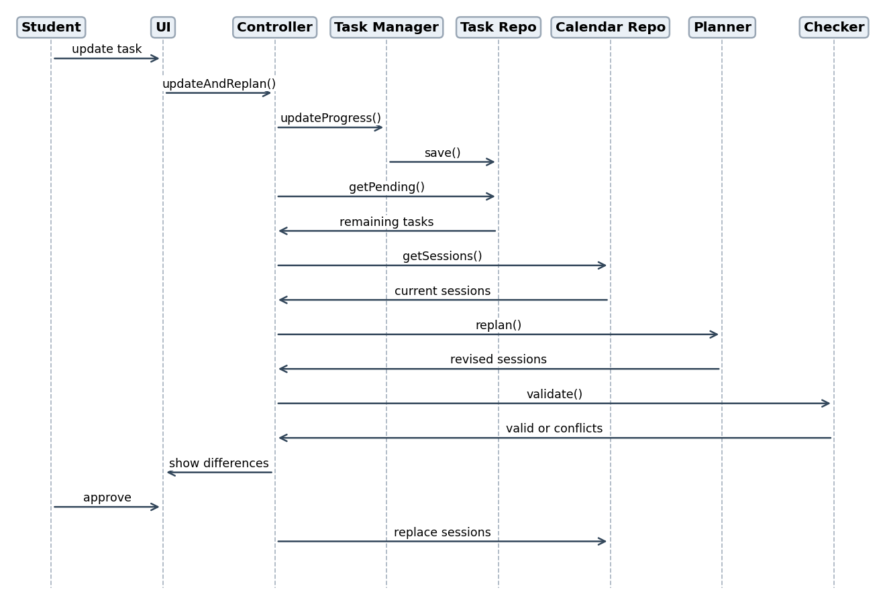
SD03 — Update progress and replan.
Alternative flow: If revised sessions cannot fit, the previous schedule is preserved.
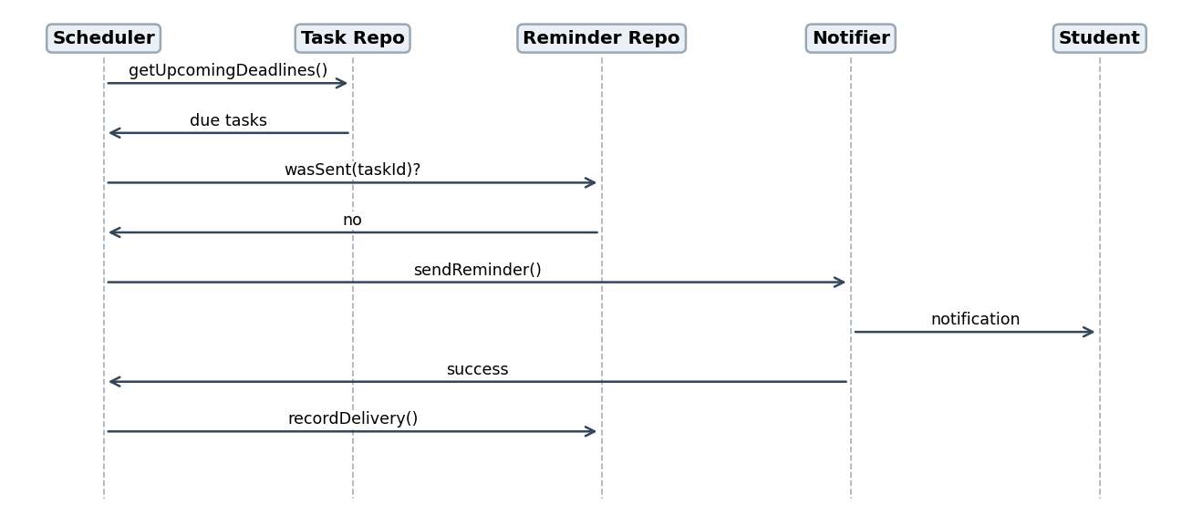
SD04 — Send a deadline reminder.
Alternative flow: Failed notifications remain pending and can be retried.
SD05 — Natural-language request and CLI entry: Student → GUIView/CLIView.submitRequest() → AgentController.handleRequest() → IntentInterpreter.interpret() → ILLMClient.interpret() → ToolManager.executeTool() → ICommand.execute() → AgentController → GUI/CLI result. If the model cannot classify the request, the controller asks for clarification; an unsupported CLI command displays help.
SD06 — Explain or export: Student → GUIView → AgentController → ExplanationService.explainPlan() → ILLMClient.explain() → GUIView (F11), or Student → GUIView/CLIView → AgentController → ExportService.exportCSV() → output (F12). A failed LLM explanation falls back to a rules-based summary; an invalid export format returns a validation message.

Task 3 — Feature-to-Design Traceability
Feature | Type | Use case | Classes / key methods | Sequence | Patterns
F01 | Hybrid | UC01 | GUIView, CLIView, AgentController, IntentInterpreter, ToolManager; handleRequest(), interpret(), executeTool() | SD05 | Facade, Command, Adapter
F02 | Deterministic | UC02 | TaskManager, Task, ITaskRepository; saveTask(), save() | SD03 | Facade
F03 | Hybrid | UC03 | DocumentProcessor, ILLMClient, TaskValidator; extractText(), extractTasks(), validate() | SD01 | Adapter
F04 | Hybrid | UC03 | IntentInterpreter, ILLMClient, TaskValidator; interpret(), extractTasks(), validate() | SD01 | Adapter
F05 | Deterministic | UC02/04 | IPriorityStrategy, DeadlinePriorityStrategy; rankTasks() | SD02 | Strategy
F06 | Hybrid | UC04 | SchedulePlanner, ConflictChecker, ICalendarRepository; generate(), validate(), saveSessions() | SD02 | Strategy, Facade
F07 | Deterministic | UC04 | ConflictChecker, StudySession; validate() | SD02 | Facade
F08 | Deterministic | UC05 | TaskManager, Task, ITaskRepository; updateProgress(), save() | SD03 | Facade, Observer
F09 | Hybrid | UC05 | SchedulePlanner, ConflictChecker, ICalendarRepository; replan(), validate(), saveSessions() | SD03 | Strategy
F10 | Deterministic | UC06 | ReminderScheduler, INotificationService; checkDeadlines(), sendReminder() | SD04 | Observer, Adapter
F11 | Hybrid | UC07 | ExplanationService, ILLMClient; explainPlan(), explain() | SD06 | Adapter
F12 | Deterministic | UC08 | CLIView, AgentController, ExportService; parseCommand(), handleRequest(), exportCSV() | SD05/06 | Facade, Command

Task 4 — How Each Feature Is Realized

F01 — Natural-language requests
Related use case: UC01. Related sequence diagram: SD05.
Classes and methods: GUIView, CLIView, AgentController, IntentInterpreter, ToolManager. Key methods: handleRequest(), interpret(), executeTool().
Execution: Controller interprets the request, selects permitted tools, and reports results. The GUI and CLI use the same controller and underlying services, so the feature behaves consistently in both interfaces. Unclear intent prompts a clarification; model failure offers manual navigation.

F02 — Course and task management
Related use case: UC02. Related sequence diagram: SD03.
Classes and methods: TaskManager, Task, ITaskRepository. Key methods: saveTask(), save().
Execution: Validate entered fields and store records; refresh dashboard. The GUI and CLI use the same controller and underlying services, so the feature behaves consistently in both interfaces. Invalid dates or missing titles are highlighted.

F03 — Course-outline PDF import
Related use case: UC03. Related sequence diagram: SD01.
Classes and methods: DocumentProcessor, ILLMClient, TaskValidator. Key methods: extractText(), extractTasks(), validate().
Execution: Extract PDF text, ask the model for structured items, validate and confirm before saving. The GUI and CLI use the same controller and underlying services, so the feature behaves consistently in both interfaces. Unsupported/scanned PDF or ambiguous dates require manual entry.

F04 — Deadline extraction from notes
Related use case: UC03. Related sequence diagram: SD01.
Classes and methods: IntentInterpreter, ILLMClient, TaskValidator. Key methods: interpret(), extractTasks(), validate().
Execution: Model identifies a possible deadline; validator checks date and requests confirmation. The GUI and CLI use the same controller and underlying services, so the feature behaves consistently in both interfaces. Missing or relative dates are flagged rather than guessed.

F05 — Priority ranking
Related use case: UC02/04. Related sequence diagram: SD02.
Classes and methods: IPriorityStrategy, DeadlinePriorityStrategy. Key methods: rankTasks().
Execution: PriorityEngine scores tasks using configurable rules and sorts pending work. The GUI and CLI use the same controller and underlying services, so the feature behaves consistently in both interfaces. Missing deadlines are placed in a separate review group.

F06 — Weekly study-plan generation
Related use case: UC04. Related sequence diagram: SD02.
Classes and methods: SchedulePlanner, ConflictChecker, ICalendarRepository. Key methods: generate(), validate(), saveSessions().
Execution: Agent gathers data; planner allocates slots; conflict checker validates; student approves. The GUI and CLI use the same controller and underlying services, so the feature behaves consistently in both interfaces. Insufficient time produces a partial proposal and warning.

F07 — Conflict detection
Related use case: UC04. Related sequence diagram: SD02.
Classes and methods: ConflictChecker, StudySession. Key methods: validate().
Execution: Checker compares time intervals and marks overlapping or late sessions. The GUI and CLI use the same controller and underlying services, so the feature behaves consistently in both interfaces. Invalid intervals are rejected with an explanation.

F08 — Progress tracking
Related use case: UC05. Related sequence diagram: SD03.
Classes and methods: TaskManager, Task, ITaskRepository. Key methods: updateProgress(), save().
Execution: TaskManager validates and persists changes, then refreshes the view. The GUI and CLI use the same controller and underlying services, so the feature behaves consistently in both interfaces. Unknown task or negative effort is rejected.

F09 — Automatic replanning proposal
Related use case: UC05. Related sequence diagram: SD03.
Classes and methods: SchedulePlanner, ConflictChecker, ICalendarRepository. Key methods: replan(), validate(), saveSessions().
Execution: Controller fetches current state; planner proposes changes; checker validates; user approves. The GUI and CLI use the same controller and underlying services, so the feature behaves consistently in both interfaces. If no valid solution exists, show unresolved tasks and keep the old plan.

F10 — Deadline reminders
Related use case: UC06. Related sequence diagram: SD04.
Classes and methods: ReminderScheduler, INotificationService. Key methods: checkDeadlines(), sendReminder().
Execution: Scheduler finds eligible tasks, checks delivery history, and notifies once. The GUI and CLI use the same controller and underlying services, so the feature behaves consistently in both interfaces. Failed deliveries are retried and duplicate alerts suppressed.

F11 — Study-plan explanation
Related use case: UC07. Related sequence diagram: SD06.
Classes and methods: ExplanationService, ILLMClient. Key methods: explainPlan(), explain().
Execution: ExplanationService prepares verified scheduling facts for the LLM to summarize. The GUI and CLI use the same controller and underlying services, so the feature behaves consistently in both interfaces. If the model fails, show a template-based explanation.

F12 — Plan export and CLI access
Related use case: UC08. Related sequence diagram: SD05/06.
Classes and methods: CLIView, AgentController, ExportService. Key methods: parseCommand(), handleRequest(), exportCSV().
Execution: Shared controller retrieves schedule and ExportService formats the result. The GUI and CLI use the same controller and underlying services, so the feature behaves consistently in both interfaces. Invalid commands/formats display help without changing data.

Stage 2 Implementation Notes
I would first implement the Task, Course, and StudySession models and SQLite repositories, followed by priority scoring and conflict-free scheduling. Next I would connect the GUI and CLI to AgentController, then add PDF parsing and the LLM adapter. Finally, I would add reminders, exports, and tests for invalid dates, overlapping sessions, unavailable AI services, and rejected schedule changes. This order makes the core planning features usable even before the AI integration is complete.

Submission Checklist
The course instructions require the Stage 1 report to be committed to a public GitHub repository used across all three project stages. After uploading the report, the student submits the repository URL through the course submission system. The report should be pushed before the deadline and the link checked for accessibility.

